**DEVELOPMENT OF NSTP SYSTEM FOR TECHNOLOGICAL UNIVERSITY OF THE PHILIPPINES - CAVITE CAMPUS**

**A RESEARCH PROJECT**

Presented to the Faculty of

**Department of Industrial and Technology**

Technological University of the Philippines - Cavite Campus

Carlos Q. Trinidad Avenue, Salawag, Dasmariñas City, Cavite

By

**Ala, John Christopher D.**

**Jumalon, Joshua C.**

**Manuel, Leomhar**

**Rapal, Christian C.**

**Seña, Renshi Angelo G.**

In Partial Fulfillment of the Requirements for the Degree

**Bachelor of Engineering Technology**

**Major in Computer Engineering Technology**

**May 2022**

**Chapter 1**

**INTRODUCTION**

**Background of the study**

The evolution of Technology nowadays increasingly gives higher impacts to users all over the world. Computer Technology is the basic necessity in modern everyday life. It has made most of the daily activities easier, faster and more accurate. It is also used for communicating or even from the other sectors that uses computers with internet connectivity, in which people can access anytime the different websites like Facebook that most us or even children can access. It serves as a tool for communication across the globe. It simply makes the world smaller. Websites are intended to provide rich information and quality service. It acts as a connecting line between diverse individuals around the world. As an internet tool, it is in itself diverse in many ways depending on the content that the website provides.

Having a computerized system in an organization makes the tasks easy, because it will help to access data in a shorter period of time unlike the manual form that can duplicate errors in the part of the concerns. There is an urgent need for it at present since the numbers of members arise and the manual process of managing student records and schedule of events is no longer being practiced. This study aims to provide the organization and member’s convenience and quality management of data that would replace the manual transaction of the registration.

In the few short years since I was a former officer of the NSTP (ROTC), there are so many problems that I’ve encountered inside the organization. Number one is the lack of systematic process on how to handle the students data properly. Some cause of this is the old method of encoding data using microsoft excel and other microsoft apps. The second problem is the Print form method of enrollment which is not good because there is a large population of students who’s taking NSTP. This method leads the working place of the NSTP to a messy environment because there are a bunch of papers that contain data from the students and it will be encoded manually by the designated officers of the Unit. It can also be lost at all times and if ever this happens there is no other backup to restore. The next problem is the Slow making of certificates. Making of certificates are done manually or one by one through typing the name of each student on the provided template. So from those problems said; I came up with an Idea to develop an application or website that will take cover and make solutions to all problems.

This project aims to change the traditional manual process of the NSTP Organization to lessen the time and effort they use on every work they have. And also it can help the students to lessen their effort on registration and locating their information like grades, Platoons/Sections and other Related files of their field.

**Objectives of the Study**

The overall goal of this project is to create a web-based system for TUPC NSTP that can Keep all the students' personal information without losing it, make transactions with the Organization easier for all NSTP Students, and replace the outdated technique of handling documents inside the department.

1. Design a Web-based system that can replace the old way and unorganized method of keeping/ archiving students' data and records inside the NSTP Department.

1.1. Make easy to find records including past records of the students.

1.2.

1. Reduced the consumed time of every student by using manual filling up of forms during enrollment.
2. To develop an NSTP System that contains the following features.

3.1. A system that allows for online enrollment and securely and neatly organizes the data and other personal information of students.

3.2. A system that has a capacity to generate certificates for all students who took NSTP.

3.3. A system where staff can upload files or other lecture materials for the student to download.

3.4. A system that can connect to a custom mobile application with the purpose of tracking students attendance by scanning each ID’s during training day.

3.5. A system that makes it simple for all past students, alumni, and staff to locate records when needed.

**D. Scope and Limitations**

The main concept of this study was based on the traditional way of doing transactions in the NSTP Department.This study focuses on the innovation of the traditional way of making transactions like the handwritten filling of students on enrollment form, manual encoding of students data on Microsoft Excel and other Microsoft platforms, manual typing of students name on provided certificate template during certificate issuing, handwritten student attendance on a sheet of paper and also the manual sectioning or sorting of students. The researchers aimed to improve the traditional way of doing all transactions in the NSTP Department. This is to reduce the time of every student who manually fills out all forms needed and also for the NSTP staff who work inside the organization. This study was intended to provide a more organized and precise system that can give good service to the students and staff of the organization.

For the development and implementation of this study, students of the university can now enroll online, see their section or platoons online and also they can request documents online without any interruptions. For the faculty and staff they can work easily on this system. They can communicate to the students online and also they can easily access all the data and information of the students. Admins and staff can also track students' attendance by the use of mobile applications that are connected to the web-based system, it is called hybrid applications.

The study was only limited within the school premises, the beneficiary of this study are the NSTP Department of Technological University of the Philippines and the students of the said university who are taking the NSTP unit yearly. The students are required to submit a copy of their Certificate of Registration (COR) upon the registration to the NSTP system as part of the validation process.

**E. Significance of the Study**

The study expects that this will be useful and can give contribution to some parties, as follow:

For the ROTC officer and CWTS facilitator, they can use this web App to reach out to students on many things such as announcements about ROTC / CWTS meetings, uploading files of their lessons, and tracking their records such as attendance time of when the students enter and exit the premises.

For Students, They can easily know when and where the meeting is, so they don't have to worry about missing it. When it comes to attendance, thanks to a separate app connected to this web app, it will be recorded that their attendance is faster and easier by scanning the qr code on their i.d, and for their registration process to enroll in the Nstp.

For TUPC alumni, If they return or want to become a reservist in ROTC, they will still be able to see the necessary information, regarding to their Nstp records such as the serial number.

**Chapter 2**

**CONCEPTUAL FRAMEWORK**

This chapter presents the review of relevant literature and studies that the researchers found the importance of using web applications for management of students data, Qr code Scanner as an attendance, and online certificate generator. It also provides the research's conceptual model and the required information for the materials or software used in the development of the prototype. Lastly, the definition of terms to fully comprehend the research.

**Review of Related Literature and Studies**

**Web Application**

A web application (or web app) is application software that runs on a web browser, unlike software programs that run locally and natively on the operating system (OS) of the device. Web applications are delivered on the World Wide Web to users with an active network connection.

According to Indeed Editorial Team (2020), A web application is a client-server program. It means that it has a client-side and a server-side. The term "client" refers to the program used by the individual to run the application. It is a component of the client-server environment, in which multiple computers share information. In the case of a database, for example, the client is the program through which the user enters data. The server is the program that stores the data. This helped the Nstp system to provide the students a helpful application that makes their registration in Nstp course, generating of certificates, and for the record of their attendance so that the Nstp coordinator can easily record their attendance including the time they are in and out of the field.

**Online Student Enrollment**

Online Enrollment System has the system also includes multiple notification techniques such as SMS and email. The business rules are stored in XML, which allows the system interface to be portable to a wider range of devices, such as Personal Device Assistants (PDA) (Then, 2006) . The interface recognizes whether the user is using a PC/laptop or a device with a smaller screen, such as a PDA. In brief, the enrollment system's backend engine and front-end engine work together to create a high-quality user experience.

This research conducts the students enrollment workflow from the online enrollment of the Nstp to approval workflow, Students can enroll in their topics prior to the start of their semesters using the Nstp system. This research not only allows students from faraway areas to enroll over the internet rather than visiting the university, but it also includes business regulations.

**Certificate Generator**

The usage of computer software is widespread. Several organizations perform their daily activities more efficiently using applications founded by the use of computer science knowledge. Certificate Generation System can be used in various universities to automate the distribution of digitally verifiable mark sheets of students to ease the work. This system verifies the participants' information from the access database and generates the certificates of all the participants in a portable document format (Bharti Chikankar, Sidhant Jaiswal, 2020) .

Nstp System can generate a certificate automatically. Unlike the old way, which involved manually creating certificates and typing the student’s name into the certificates. However, in this research it used an automatic certificate generator, we can quickly create student certificates faster than the previous way and also the department staff will lessen their time and effort used on creating certificates.

**Attendance using QR code Scanner**

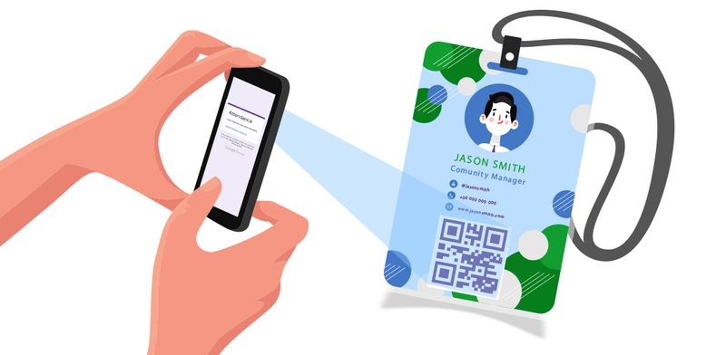

*Figure 1*. QR Code Scanner

*https://www.qrcode-tiger.com/qr-code-attendance*

QR Code technology allows you to easily check-in and out of classes and courses to verify and track your attendance. Students can simply scan in for attendance using the cameras on their mobile devices. Given the popularity of smartphones, using them to speed up the process of taking attendance by university instructors would save lecturing time and thus improve the educational process.

According to the International Journal of Advanced Computer Science and Applications (2014), Taking students' attendance during each class by university instructors is a time-consuming process, especially when classes are large. Some faculty policies require the instructor to perform this task in each lecture. In other words, up to eight hours of the total hours assigned to a given course, which is typically forty-five hours per semester, may be lost to perform this process, which typically takes around ten minutes per lecture.

In this research, a QR code scanner is used to scan the students' qr codes.

It is a separate application (mobile application) using MIT App inventor that will record the students' attendance, including the date and time they enter and exit the field. The data will be saved in sheets that will be displayed in the NSTP system.

**Related Studies**

**QR Code and Bar Code**

*Figure 1*. QR and BAR Code

*https://en.wikipedia.org/wiki/QR_code*

*https://en.wikipedia.org/wiki/Barcode*

QR codes are two-dimensional matrix barcodes. Last decade witnessed a steady growth in commercial and business oriented usage of these QR codes with the advent of smart and web capable mobile phones. But the movement of using QR codes in Library & Information field is still in its primary stage. This paper explains application of QR Codes in Library resource and service awareness activities. The present study focuses on brief introduction to QR codes along with how it works and its features. It also attempts to explain the use of QR codes in libraries, with special reference to QR code implementations in Central Library, NITK. This paper serves as a guide to all those who want to implement QR Codes in their Library.

A barcode, consisting of bars and spaces, is a machine-readable representation of numerals and characters. Today, stripes as shown below on packages of products sold at supermarkets, convenience stores and other stores are ubiquitous. These are barcodes. A barcode consists of bars and spaces of varying width that can be read with an optical barcode scanner.

**Dynamic HyerText Markup Language (DHTML)**

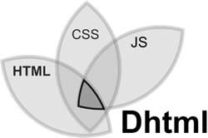

*Figure 3*. DHTML

*http://www.differencebetween.info/difference-between-dhtml-and-html5*

As mentioned in an educational website (https://www.geeksforgeeks.org/dhtml

-introduction/), DHTML stands for Dynamic HTML, it is totally different from HTML. The browsers which support the dynamic HTML are some of the versions of Netscape Navigator and Internet Explorer of version higher than 4.0. The DHTML is based on the properties of the HTML, javascript, CSS, and DOM (Document Object Model which is used to access individual elements of a document) which helps in making dynamic content. It is the combination of HTML, CSS, JS, and DOM. The DHTML make use of Dynamic object model to make changes in settings and also in properties and methods. It also makes uses of Scripting and it is also part of earlier computing trends.

**Html**



*Figure 4*. HTML

*<https://play.google.com/store/apps/details?id=in.vineetsirohi.htmlreader&hl=en_US&gl=US>*

Hayes (2020) described that HyperText Markup Language (HTML) is the set of markup symbols or codes inserted into a file intended for display on the Internet. The markup tells web browsers how to display a web page's words and images.

He also mentioned that HyperText Markup Language is the computer language that facilitates website creation. The language, which has code words and syntax just like any other language, is relatively easy to comprehend and, as time goes on, increasingly powerful in what it allows someone to create. HTML continues to evolve to meet the demands and requirements of the Internet under the guise of the World Wide Web Consortium, the organization that designs and maintains the language; for instance, with the transition to Web 2.0.

HTML, or Hypertext Markup Language, is used by researchers to create the NSTP system website pages. HTML is used by research to create text titles and headings, organize illustrations on a site page, connect to different pages within a site, and connect to multiple locations.

**CSS**



*Figure 5*. Css

*<https://1000logos.net/css-logo/>*

According to this website (https://techterms.com/definition/css) , Stands for "Cascading Style Sheet." Cascading style sheets are used to format the layout of Web pages. They can be used to define text styles, table sizes, and other aspects of Web pages that previously could only be defined in a page's HTML. CSS helps Web developers create a uniform look across several pages of a Web site. Instead of defining the style of each table and each block of text within a page's HTML, commonly used styles need to be defined only once in a CSS document. Once the style is defined in cascading style sheet, it can be used by any page that references the CSS file. Plus, CSS makes it easy to change styles across several pages at once.

CSS specifies how HTML elements should appear on screen, paper, or in other media. CSS saves a significant amount of time. It was used by researchers to control the layout of multiple web pages at the same time. CSS is required in this research because it is used to define table cell padding, the style, thickness, and color of a table's border, and padding around images and other objects in this research.

**JavaScript**



*Figure 6*. JS

*https://1000logos.net/javascript-logo/*

Megida (2021) stated that JavaScript is a dynamic programming language that is used for web development, web applications, game creation, and a variety of other things. It enables you to add dynamic features to web sites that would otherwise be impossible to achieve with only HTML and CSS. For doing dynamic tasks on the web, several browsers provide JavaScript as a scripting language. To mention a few features, you'll witness the benefits of JavaScript whenever you see a click-to-show dropdown menu, extra content added to a page, or dynamically changing element colors on a website.

**Python Web Framework**

According to Habib (2016), There is a wide variety of Python frameworks that make creating web applications much easier. These frameworks bring together the modules and packages that allow you to build applications quickly, without the need to take care of involved details, like sockets and protocols, all in one place. While most modern Web frameworks are used on the server, some are beginning to incorporate code that lets them run code on the client (e.g. Skulpt or Trinket). Python frameworks are often separated into full-stack and non-full-stack frameworks. Full-stack frameworks help developers create applications from the user experience right through to the database. Non-full-stack frameworks are those that handle anything less than complete development.

**Django**



*Figure 7*. Django

[*https://destatic.blob.core.windows.net/images/django-logo.png*](https://destatic.blob.core.windows.net/images/django-logo.png)

This website (https://www.djangoproject.com/) stated thatDjango is a high-level Python web framework that enables rapid development of secure and maintainable websites. Built by experienced developers, Django takes care of much of the hassle of web development, so you can focus on writing your app without needing to reinvent the wheel.

Django, an open-source framework, and a popular high-level Python web framework that enables rapid web development and design. In this study, Django is used by the researcher as a Python web framework. This assists researchers in avoiding common security blunders. The user authentication system of this framework provides a secure way to manage user accounts and passwords, and it can take web applications from concept to launch in hours.

**XAMPP**

**

*Figure 8*. Xampp

*https://cdn.freelogovectors.net/wp-content/uploads/2021/02/xampp-logo-freelogovec*

*Tors.net_.png*

XAMPP is an acronym that stands for Cross-Platform, Apache, MySQL, and PHP and Perl. The Apachefriends stated that it is an open-source web solution package that includes Apache distribution for many servers and command-line executables, as well as modules such as Apache server, MariaDB, PHP, and Perl.

A platform that provides a suitable environment for testing and verifying of Nstp system functionality. XAMPP helps a local host or server to test its website and clients via computers and laptops before releasing it to the main server.

**Database Software Program**

According to this website (https://www.oracle.com/ph/database/ what-is-database/), A database is a structured collection of information or data that is typically stored electronically in a computer system. A database management system is usually in charge of a database (DBMS). The data and the DBMS, as well as the applications that are associated with them, are collectively referred to as a database system, which is frequently abbreviated to just database.

A software program for storing the data gathered in this study. Every query in the Nstp system was recorded here, including the registration data of the students, attendance which is the time they in and out in the field and the records of all students related to Nstp included the alumni.

**Conceptual Model of the Study**

This study's conceptual model included a design thinking methodology that provided a solution-based approach to problem solving. A design thinking model was used to solve complex problems that arise in our environment. Figure 8 shows the stages of design thought.

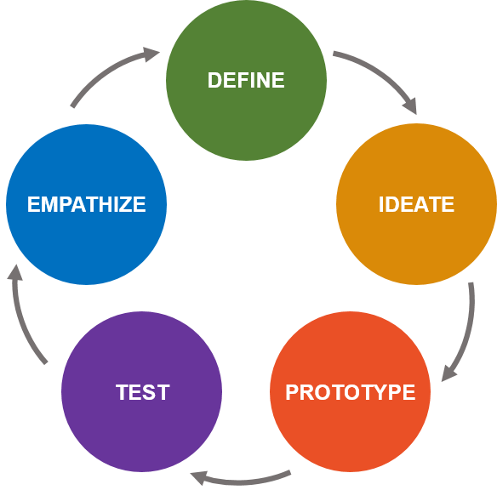

*Figure 9.* Design Thinking Model

[*https://www.lc-global-us.com/hubfs/Design_Thinking_Meets_Systems_Thinking_---_Johne_Reaves_-_LC_GLOBAL_Consulting_Inc_-_Change_and_Innovation_Firm_New_York_NY_2016.png*](https://www.lc-global-us.com/hubfs/Design_Thinking_Meets_Systems_Thinking_---_Johne_Reaves_-_LC_GLOBAL_Consulting_Inc_-_Change_and_Innovation_Firm_New_York_NY_2016.png)

In order to conduct research, the researchers devised a problem that was in the empathize stage. The researchers spent time observing the Nstp on how the management in Nstp of TUPC registers students, conducts the attendance of each student, and how the Nstp coordinator organizes student certification. Taking the students attendance took a lot of time due to the excessive number of students. As a result, too much time was consumed and wasted the process that happens just getting their attendances. Based on their observations students confirmed their attendance by writing their names and sections on a piece of paper.

The define stage followed, which addressed the researchers' initial solution to be implemented based on the gathered cause and effect of the problem. The researchers wanted to propose a solution that used QR code scanning to take students' attendance in order to save time and eliminate the traditional method of taking attendance, which required students to write their name and section on a piece of paper.

And Using an automated certificate generator to produce a certificate more quickly than the old method. Unexpected errors such as unreadable writings of the students name, course, and other human errors may arise as a result of this process. As a result of these issues, This research can provide a more secure process between the Nstp department and students in terms of taking attendance, generating certificates, and getting the necessary data from each student.

The ideate stage of the design thinking process was the third stage. The researchers were ready to start brainstorming. Researchers created a Web-based Nstp system for this study. The researcher considered the availability of Nstp departments (Rotc officers) to assist students in scanning the QR code in their I.D. for attendance, with the expectation that this solution would reduce the amount of time students spent on the task. To narrow it down, the researchers devised a feasible solution, which was the creation of a Web-based Nstp system. The goal of this study was to maximize productivity while minimizing wasted effort. The researchers' prototype was almost no cost but performed an excellent results.

The design thinking model's prototype stage consisted of how the prototype was created by researchers. The researchers happened to gather materials or components for this study. The PC serve as the prototype's brain. Because all of the functions were connected in this component, and the cellphone was used as a QR code scanner for taking student attendance. The researchers intended to create a web application for creating the Nstp system and a mobile application for making a QR Code scanner capable of saving the data needed by the Nstp system for the project's software requirement.

The researchers tested their prototype in the final stage, which was the test stage. The researchers conducted a series of tests after creating the software, which was the Web-based Nstp system, to see if there was an error or a problem. Researchers examined the software application's functionality, including student registration, certificate generation, and attendance accuracy. If problems or errors arise, troubleshooting procedures will be used to modify the prototype. A series of tests were repeated until no errors were found. The prototype was judged on its functionality, accuracy, reliability, speed, and usability.

**Knowledge Requirements:**

Concepts of Web Application

Concept Mobile Application

Concept of internet

**Software Requirements:**

Mobile Programming

Web Programming

**Software Design**

**Creation of Web Application**

**Creation of Mobile Application**

**System Testing**

**Web - Based Nstp System**

*Figure 10*. Conceptual Framework

**Definition of Terms**

**Web Application** - A web application is software that runs on a web browser, as unlike to software programs that run locally and natively on the device's operating system. Users with an active network connection can access web applications via the World Wide Web.

**Qr Code Scanner - A** QR code is a type of matrix barcode. A barcode is a machine-readable optical label that contains data about the item, in this research it contains the name of the students and use to scan ht QR code that attached in their I.D.

**Certificate Generator -** it is a fixed layout where the user manage make a certificate multiple times, user only needs to customize the information that will be included in the certificate.

**DHTML -** Dynamic HTML, or DHTML, is a term used by some browser vendors to describe the combination of HTML, style sheets, and client-side scripts that allowed the creation of interactive and animated documents.

**HTML -** The HyperText Markup Language or HTML is the standard markup language for documents designed to be displayed in a web browser. It can be assisted by technologies such as Cascading Style Sheets and scripting languages such as JavaScript.

**CSS -** Cascading Style Sheets is a style sheet language used for describing the presentation of a document written in a markup language such as HTML. CSS is a cornerstone technology of the World Wide Web, alongside HTML and JavaScript.

**JS -** JavaScript is a dynamic computer programming language. It is lightweight and most commonly used as a part of web pages, whose implementations allow client-side script to interact with the user and make dynamic pages. It is an interpreted programming language with object-oriented capabilities.

**Web Framework -** It is a software framework that was developed in order to simplify the web development process and make it easier to build a website. It includes templating capabilities that allow you to present information within a browser, provides an environment for scripting how information flows and also contains many application programming interfaces (APIs) for gaining access to underlying data resources. Most frameworks also provide tools in order for web developers to build a content management system (CMS) for managing digital information on websites and the Internet.

**Django -** Django is a free and open-source, Python-based web framework that follows the model–template–views architectural pattern. It is maintained by the Django Software Foundation, an independent organization established in the US as a 501 non-profit.

**XAMPP -** Xamppis a free and open-source cross-platform web server solution stack package developed by Apache Friends, consisting mainly of the Apache HTTP Server, MariaDB database, and interpreters for scripts written in the PHP and Perl programming languages.

**Database-** A database is a logically organized collection of structured data kept electronically in a computer system. A database management system is usually in charge of a database (DBMS).

**CHAPTER III**

**Methodology**

This chapter contained the isometric drawings of the proposed project design, the block diagram, and the flowchart related to the process of the study. This also showed the different figures of components for the development of this project. The operation, testing, and the evaluation procedures of the prototype was also included.

**Project Design**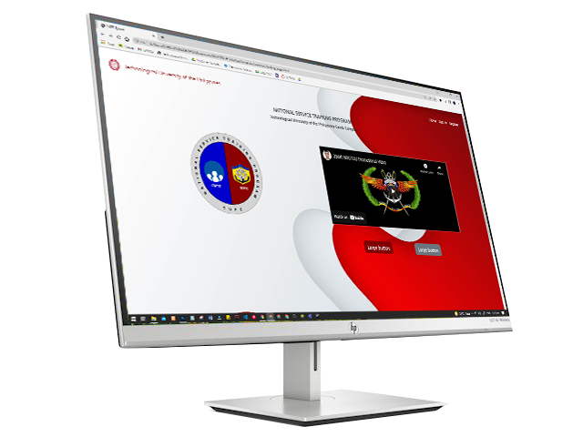

*Figure 11.* Web Application

In figure 11, it shows the interface of the proposed system (Web application). It was applicable to any computer devices and mobile phones with an internet connection. The researchers used computers as the primary medium to implement the proposed system and mobile was the secondary. The system requires the users to register to have full access to the system. Meanwhile if the one who will use is not registered yet they will be able to use the system also with the limited feature like searching their names if they have a record to the NSTP and they can also send direct email through the emailfield provided.

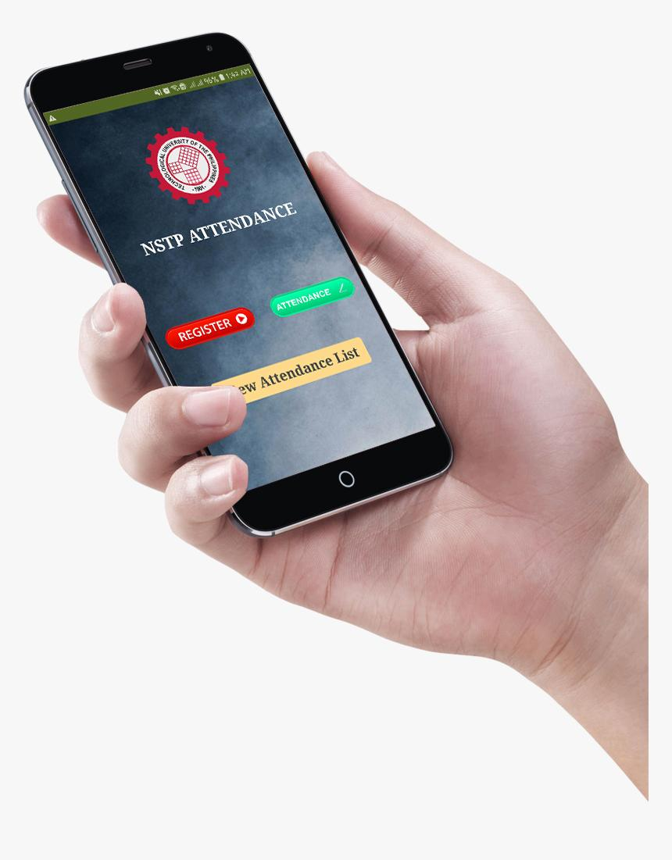

*Figure 12.* Mobile App Design (Attendance QR Code Scanner)

The mobile app's UI, which is also linked to the researchers' suggested online application, is shown in *Figure 12.* This program's function is to automate student attendance. The first step in this process was to register each student's ID, and the second step involved scanning it to track attendance. This application was exclusively for the admin and staff members who would be checking attendance on training days.

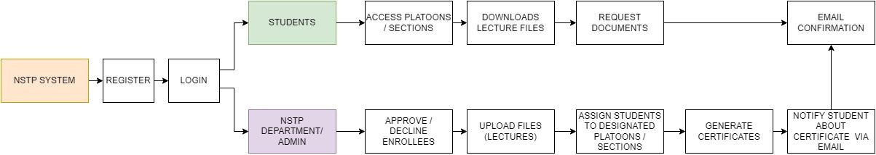

*Figure 11*. Block Diagram for Proposed System

*Figure 11* shows the block diagram of the proposed system. A block diagram is a system's representation of its main components or functions through the use of blocks connected by lines that reveal the connections between the blocks. They play a significant role in the design of hardware, electronics, software, and process flow diagrams in engineering. The starting part of the diagram was the NSTP System where all the process happens. First the users will register to create their account then continue to login. After logging in they will be able to access the system features. After they have created their account, the administrator of staff is responsible for reviewing the student's profile and they have the power to accept/decline the student’s application based on their information. Also in addition to the registration part, it is required to upload the photocopy of the Certificate of registration (COR) to be used as medium to recognized as active enrollee of the said school year. The proposed system has also a part where the staff or admin can upload the lecture files and it can be also downloaded by the students. The system has also a part of generating certificates that the students have requested and in addition is the email notification that serves as the medium of connection between students and staff of the NSTP Department.

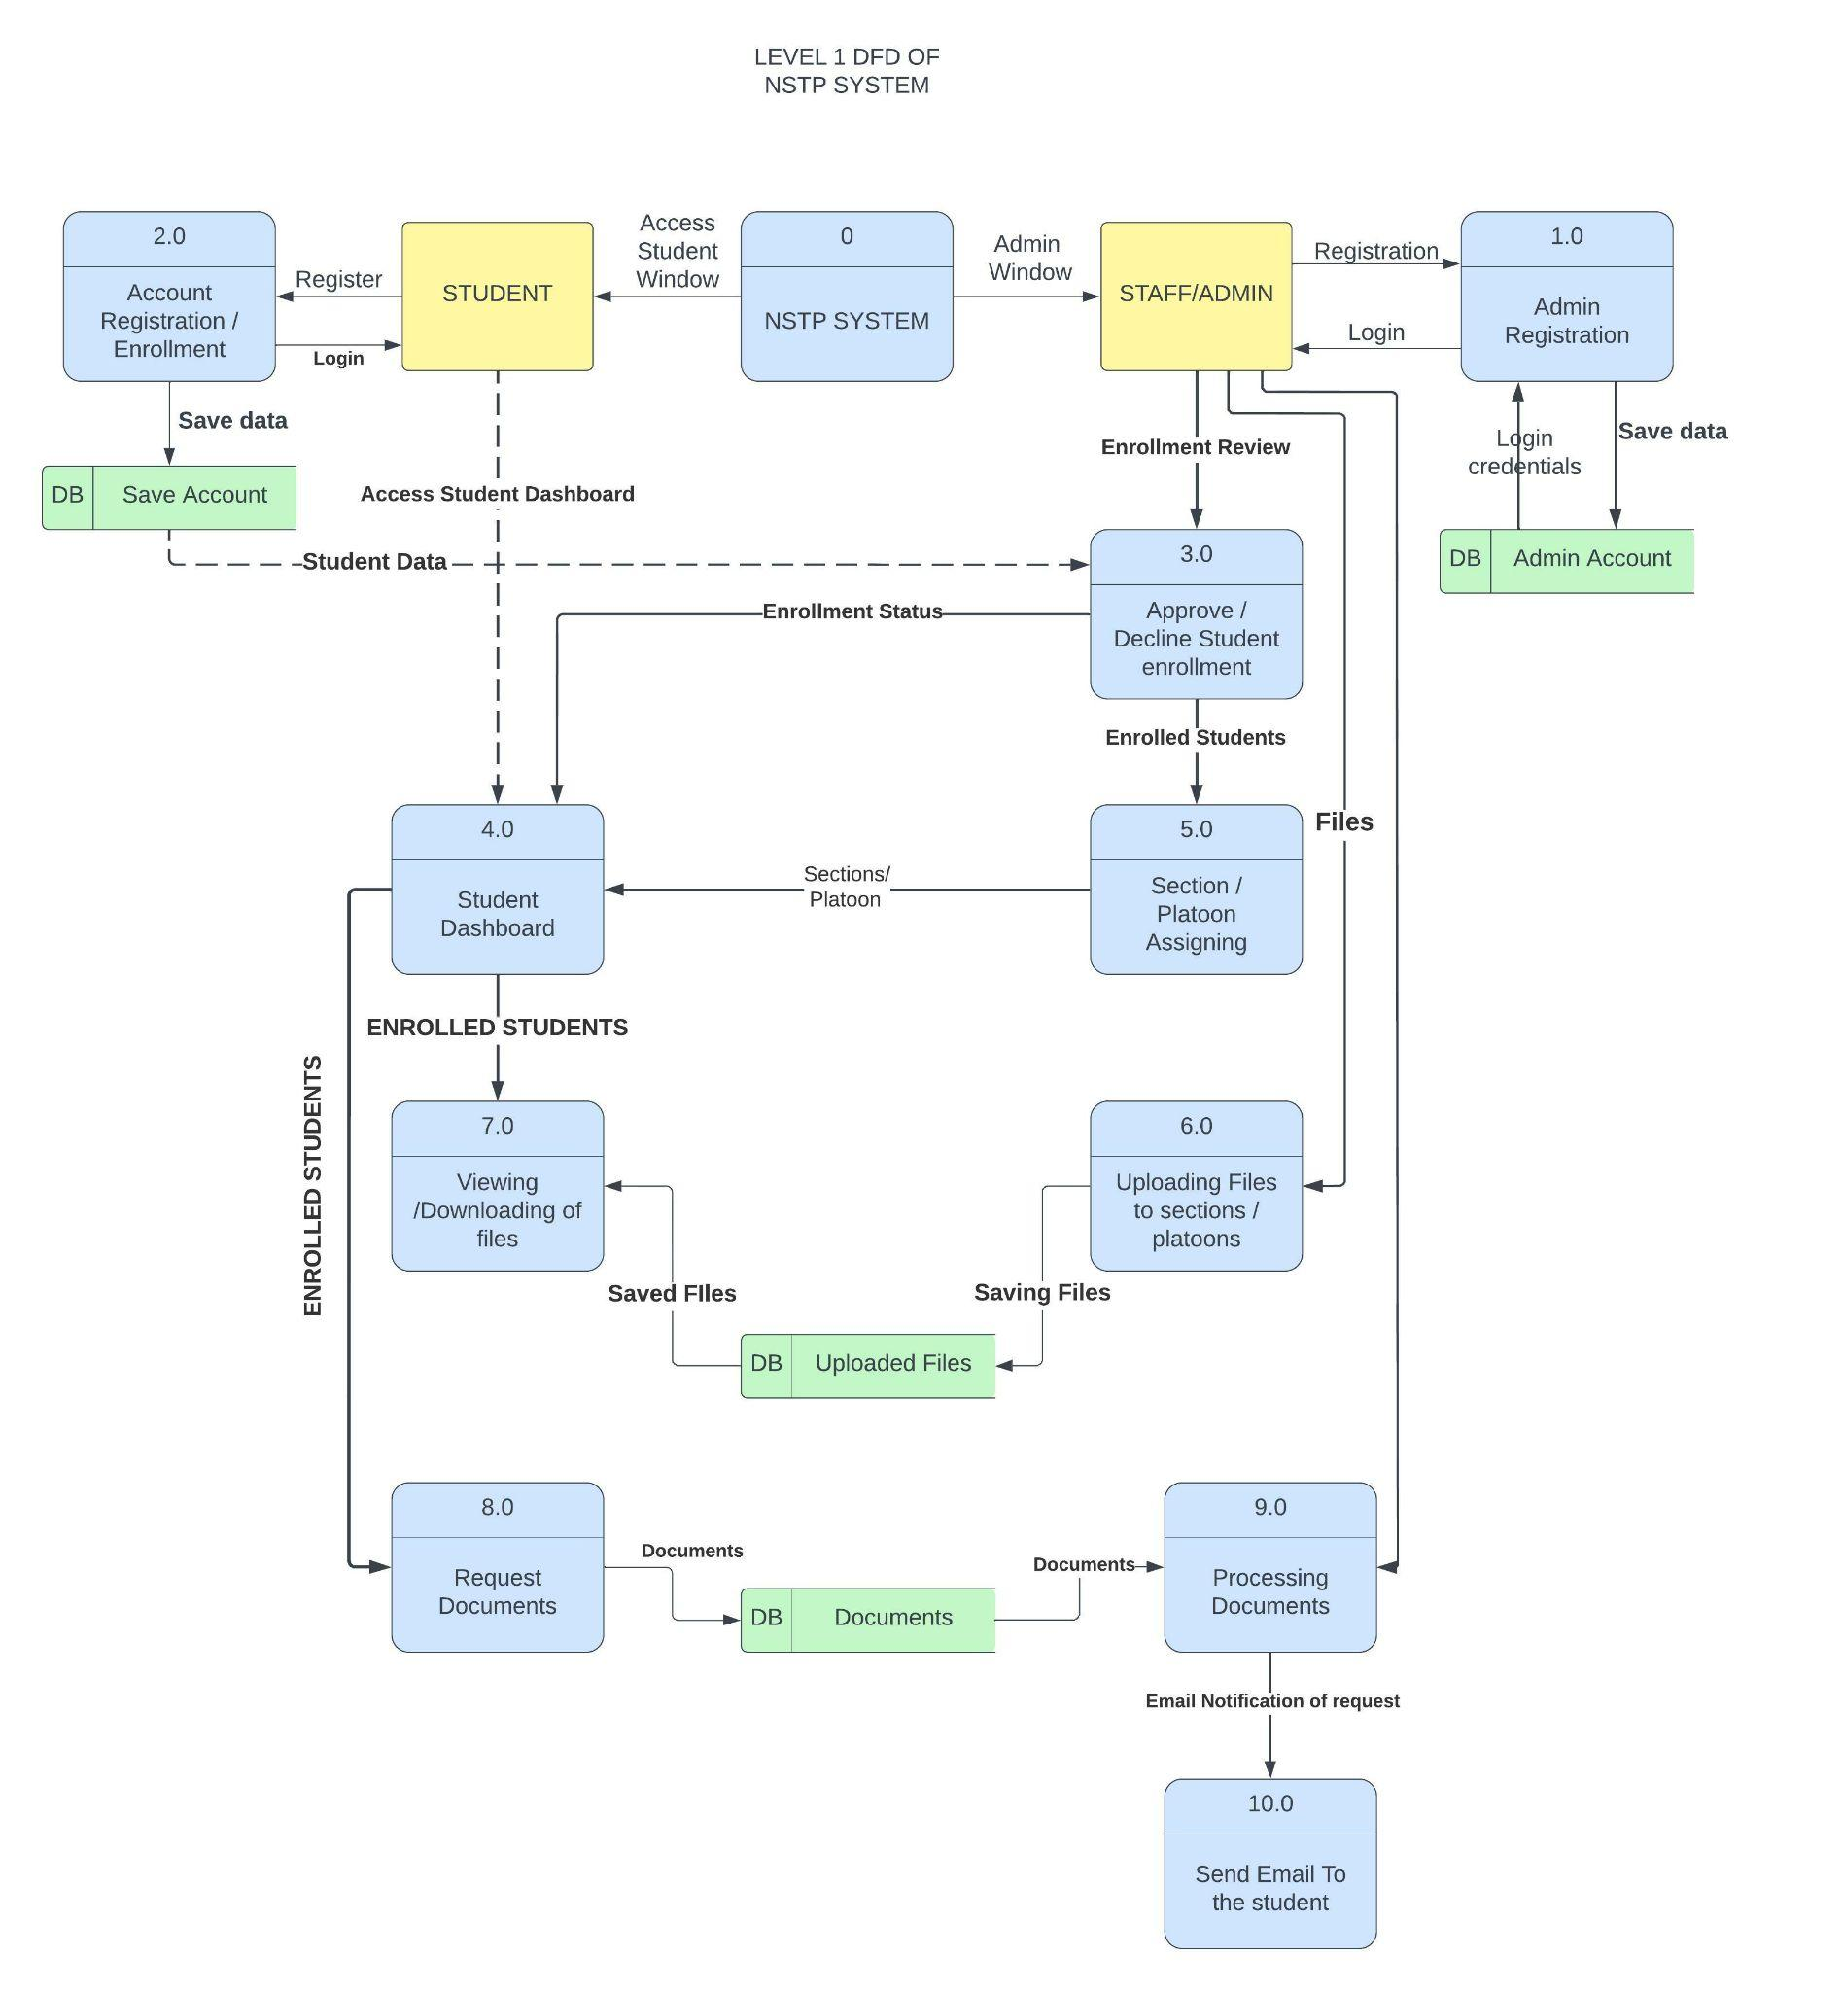

*Figure 12:* Data Flow Diagram

*Figure 12* shows the Data flow diagram of the proposed system. The students of Technological University of the Philippines-Cavite will be the users of the proposed system. The first step was the registration of the students and it will serve as their enrollment. Once the student enrollment was approved by the admin, the status of enrollment will be “APPROVED” and it will be displayed at the student’s dashboard. The user is able to login and access the NSTP System Student’s User Interface (UI). When they come to the system they will be able to do usual things like view and download files, edit their information, monitor their enrollment status and also they can request documents using the provided page inside the system. All of the students' actions inside their respective accounts also have a corresponding action from the staff or instructors who use the admin part of the system. Before the students get enrolled their information was reviewed by the staff like the photocopy of their Certificate of registration (COR) which is highly required to complete the enrollment process. The next was the Uploading of files which is also done by the Staff of the department as well as the confirmation of the document requested by the students and. Lastly is the email notifications from the NSTP Department for the students who request documents and for those who have an issue or any related problems regarding their Informations.

**Project Development**



*Figure 13; Landing Page*

Figure 13 shows the Landing page of the Proposed System. This is the way of administration and students to access their Account by logging in.

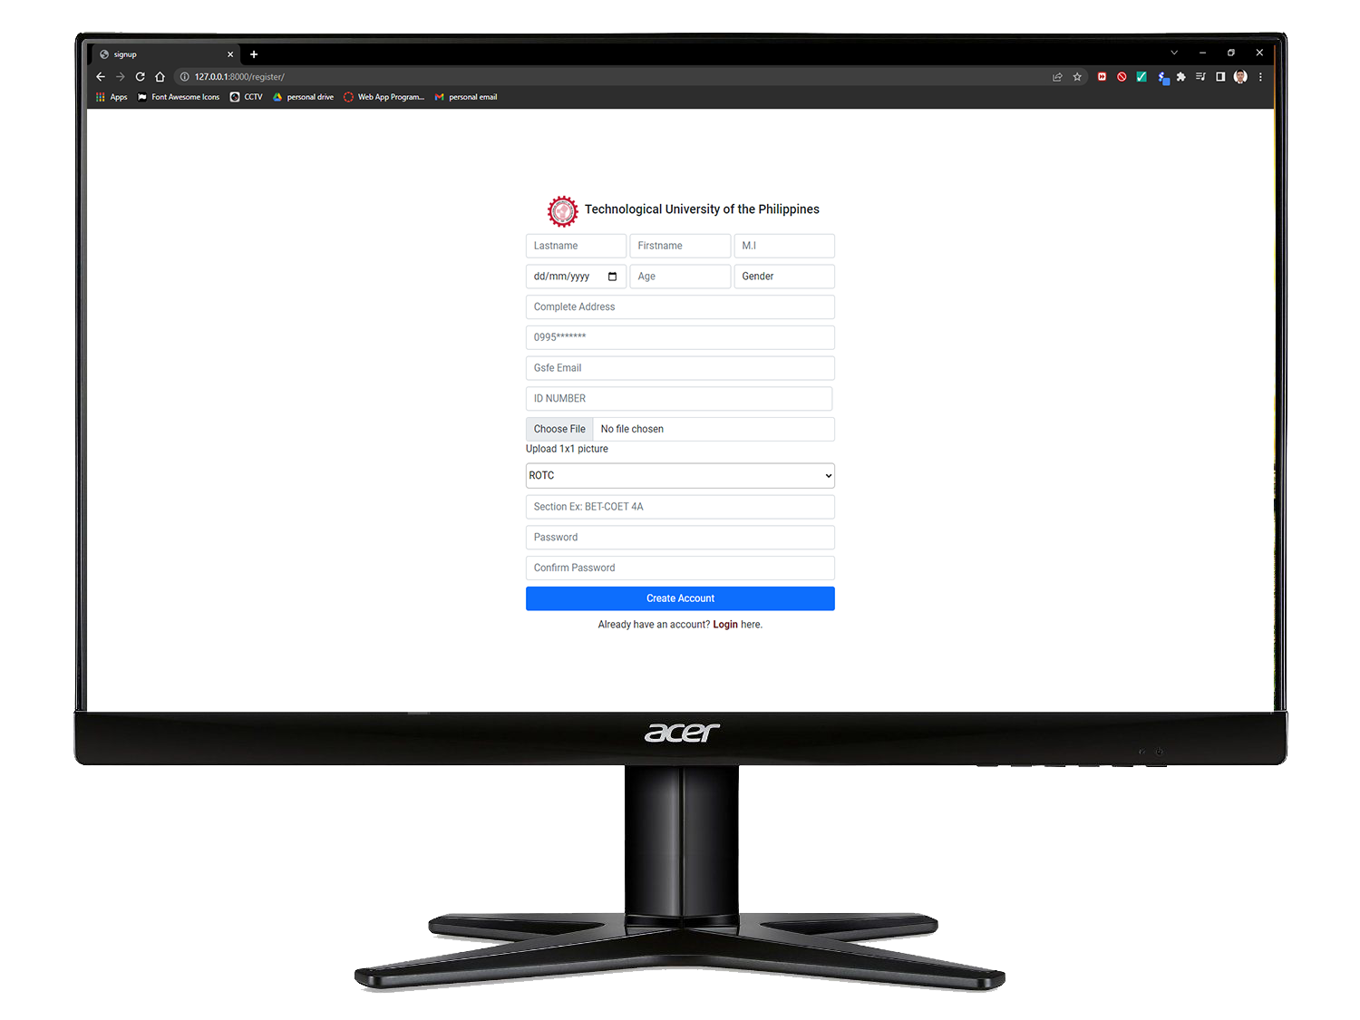

*Figure 14; User Sign Up Page*

Figure 14 shows the registration page of the system. This is the page where the students will input their information and all required data to create their account as well as to register. Once the student is registered they will be able to login and access their account on this Proposed system.

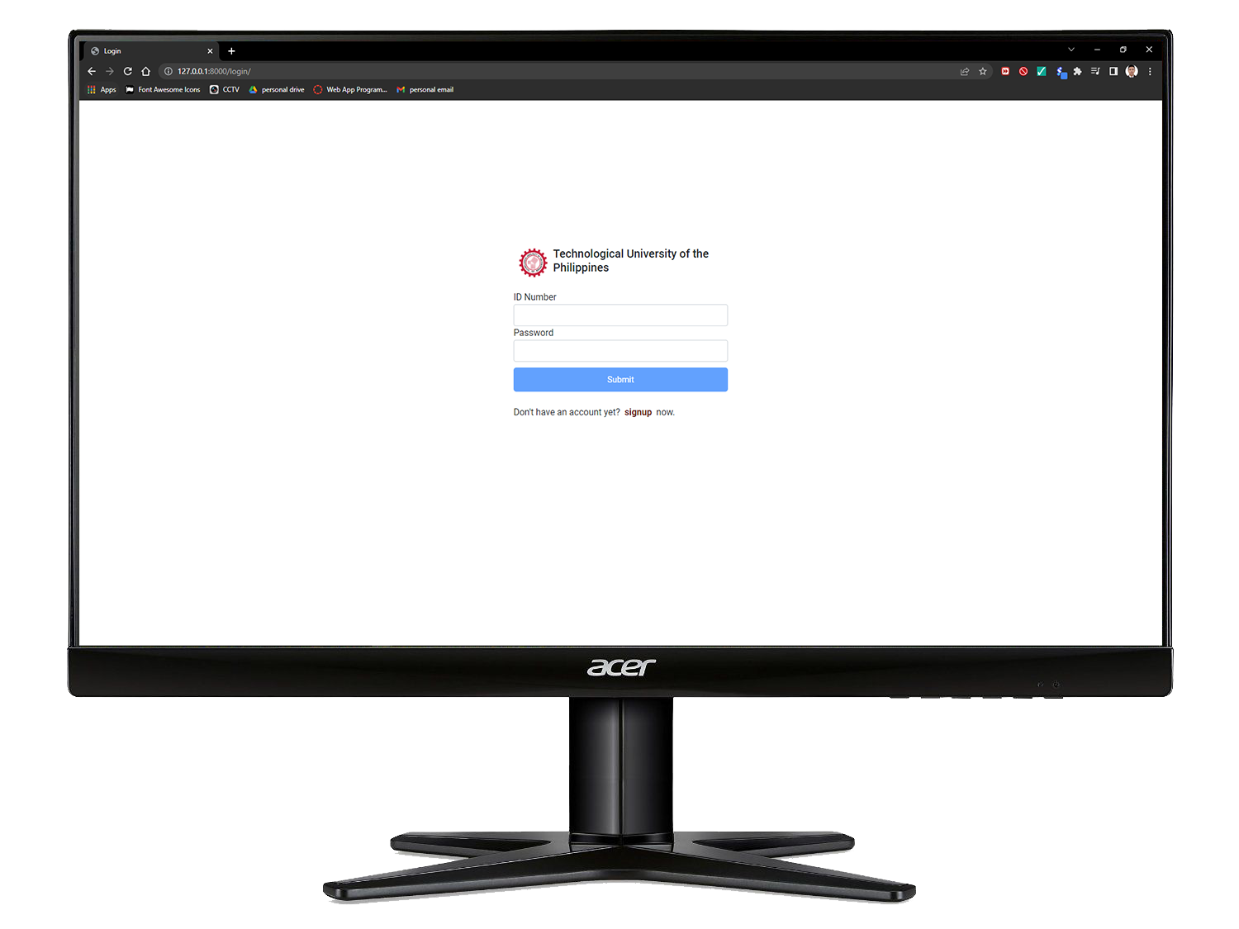

*Figure 15; User Login Page*

Figure 15 shows the Login page of the system. All the users can do is to input their username and password. If their username and password is true they can access the system else if not, there is an error message that will prompt them to re-type again their username and password.

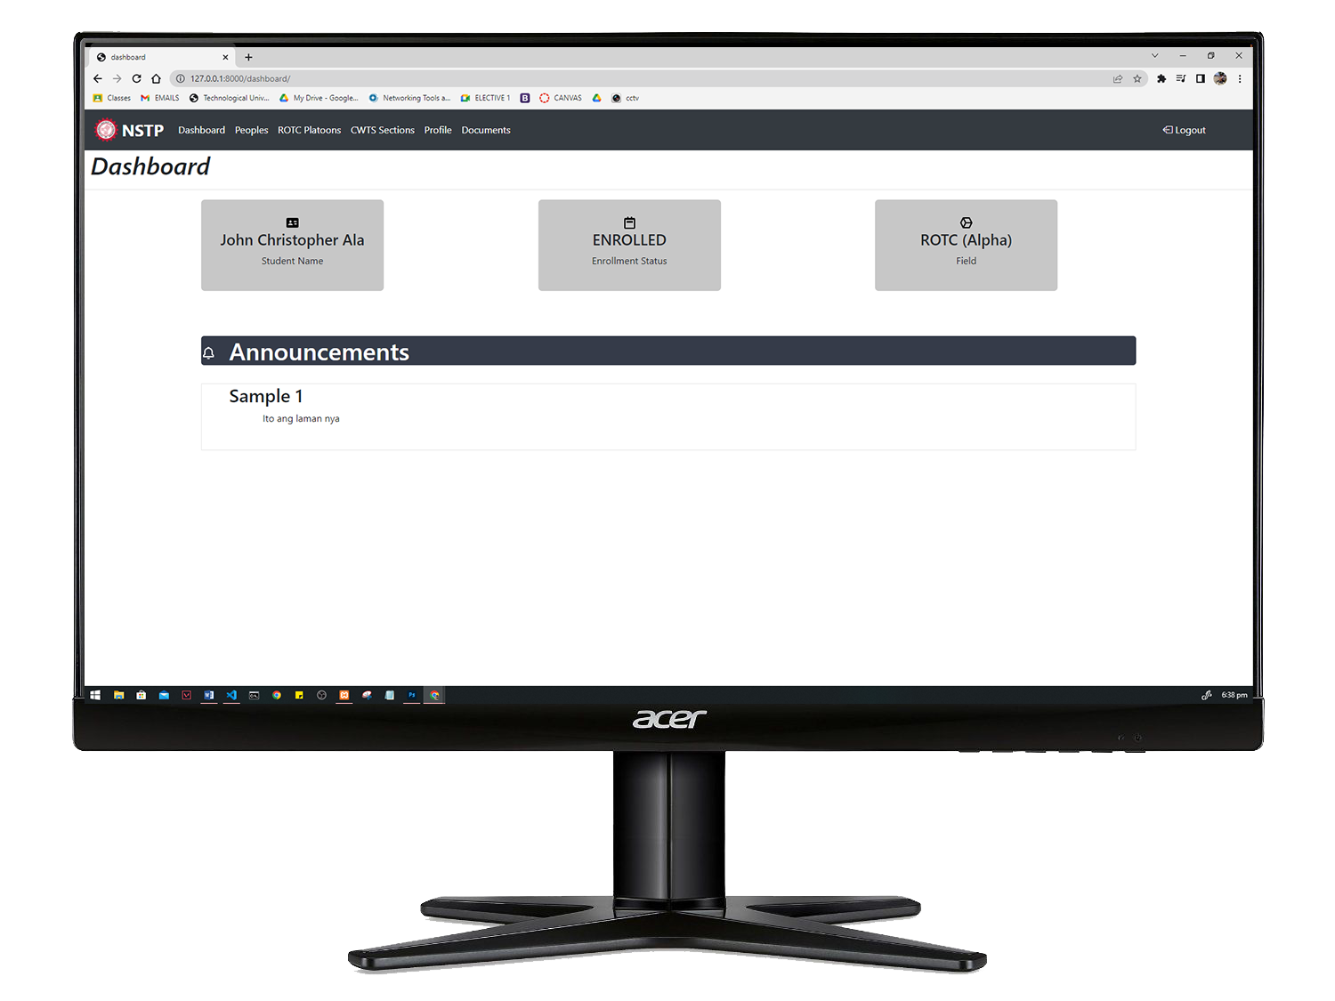

*Figure 16; Student Dashboard*

Figure 16 shows the student dashboard. This is the page where they can see their relevant information like their name, Enrollment status, section or platoon and also the general announcements.

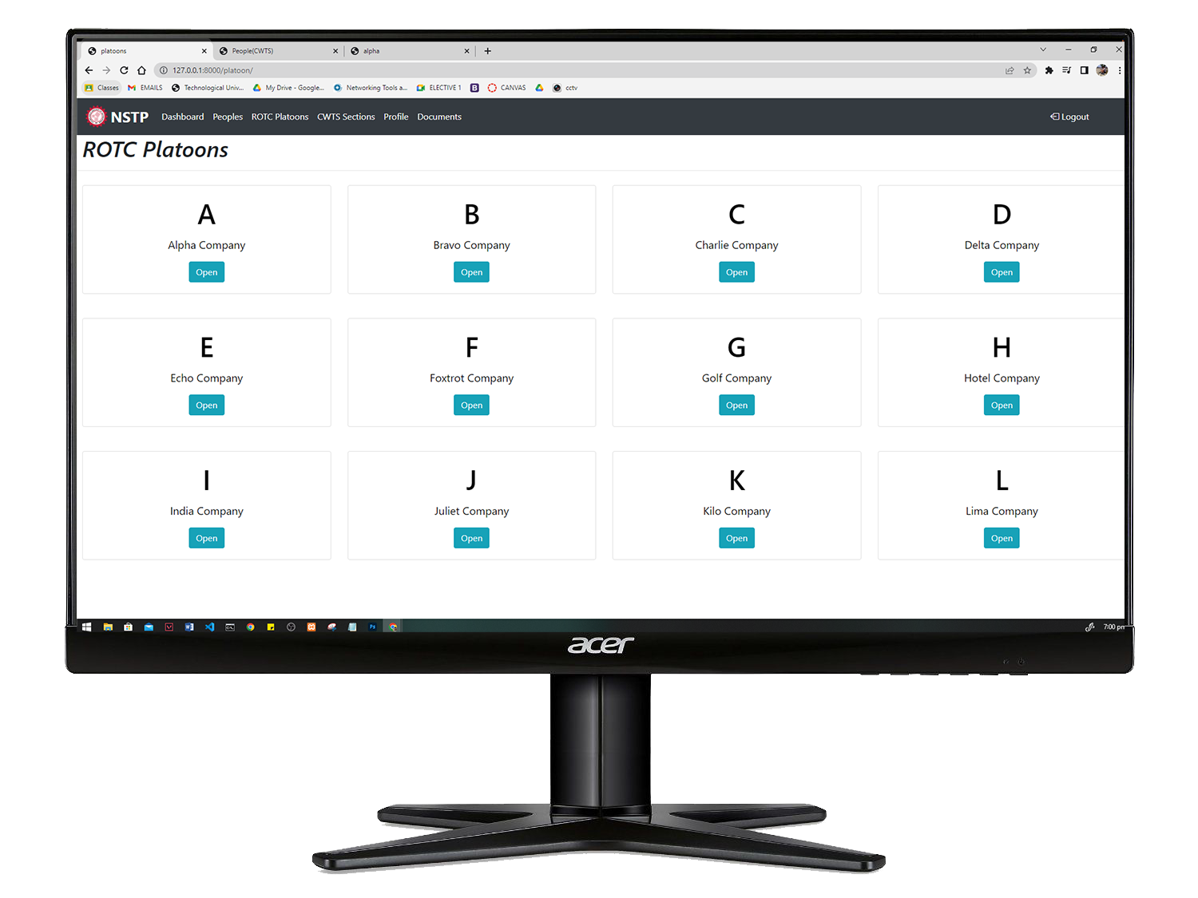

*Figure 17; ROTC Platoons*

Figure 17 shows the Cards of rotc platoons. This is where all files of the lectures have been uploaded after the training day. The Students can download the file for their personal purpose like for review or for sharing to others.

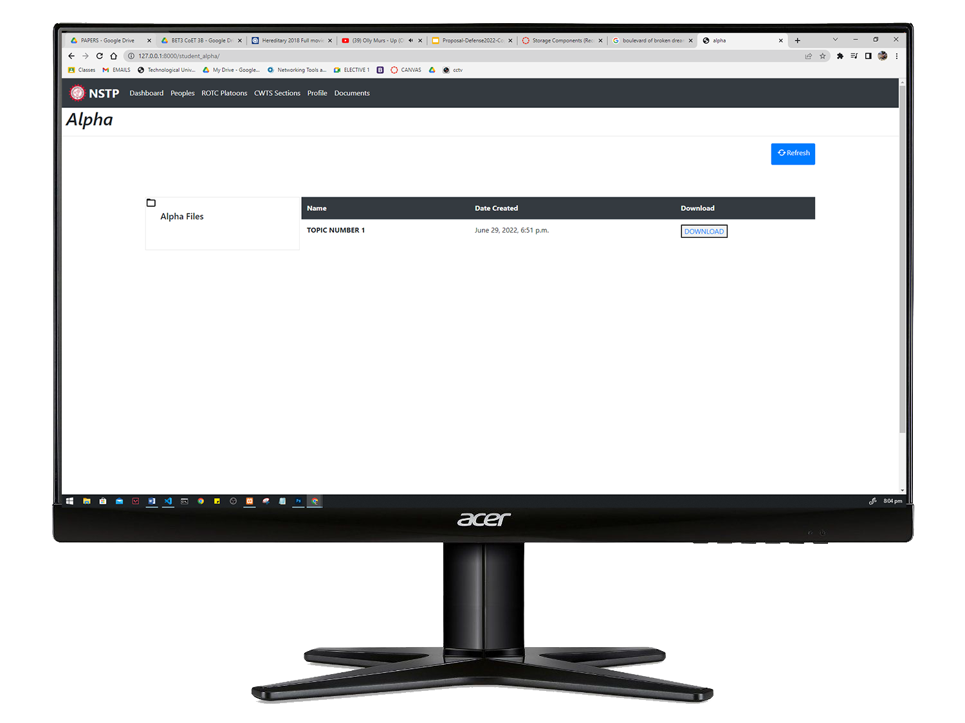`*Figure 18; Platoons FIles*

Figure 18 shows the Interface inside the Platoons. Inside the platoons there are no other contents but just the files. And those files are uploaded by the instructors who manage the designated platoon or sections.

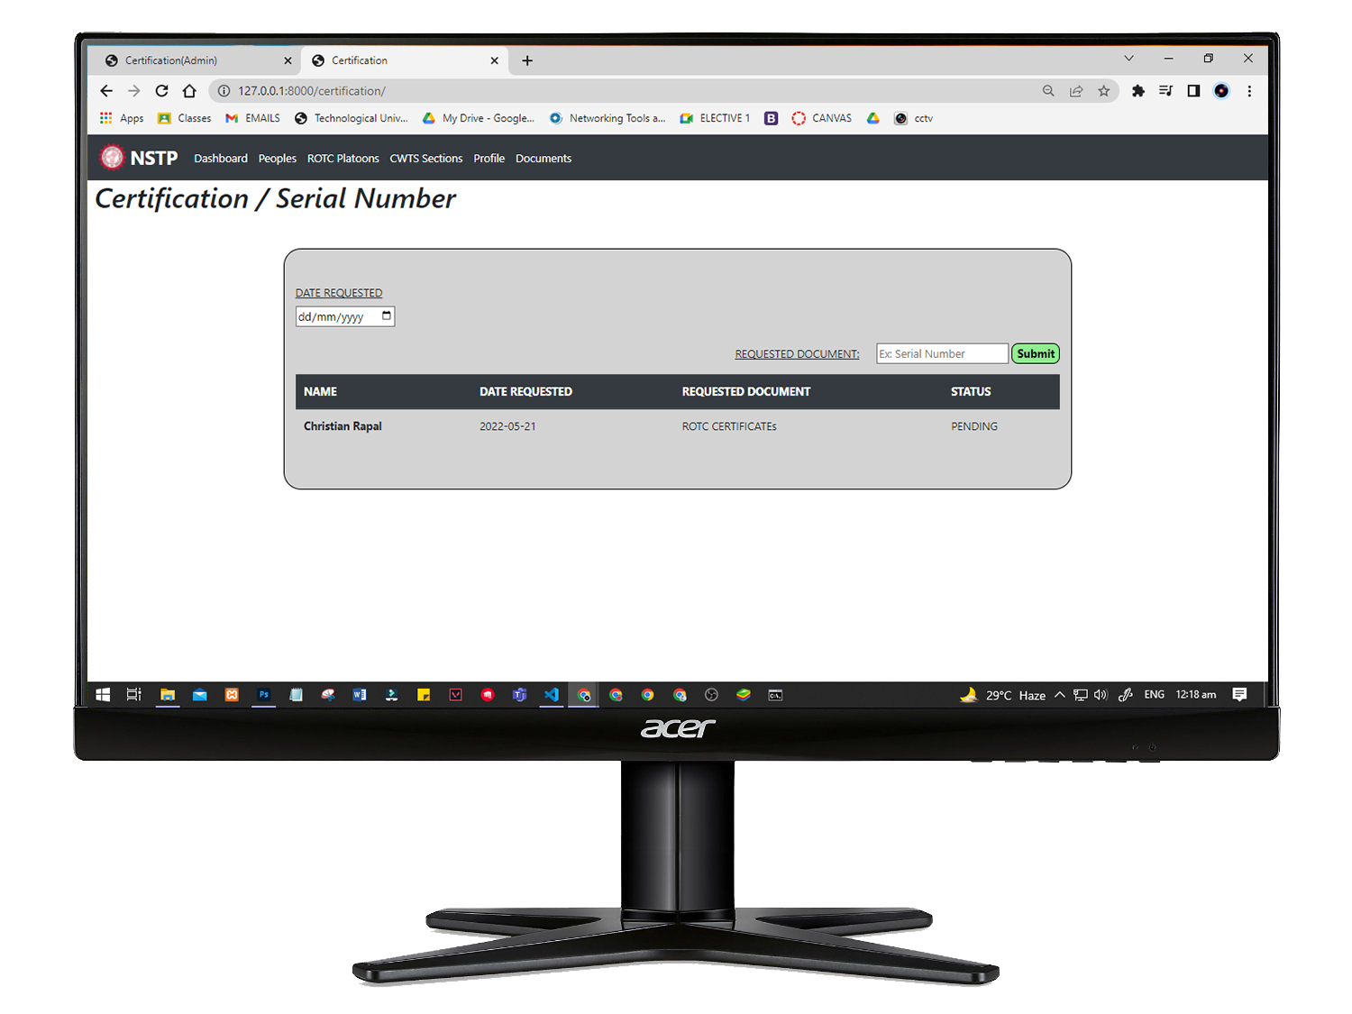

*Figure 19; Student Request Page*

Figure 19 is the draft User Interface(UI) of the proposed system for Requesting of documents. This is where the student will type their Documents needed like Certificate or other papers including serial number, but serial number as of now will be claimed to Fort Bonifacio Taguig., So the possibility of requesting it will be fast but this will be claim to the headquarters of the Philippine Navy Taguig.

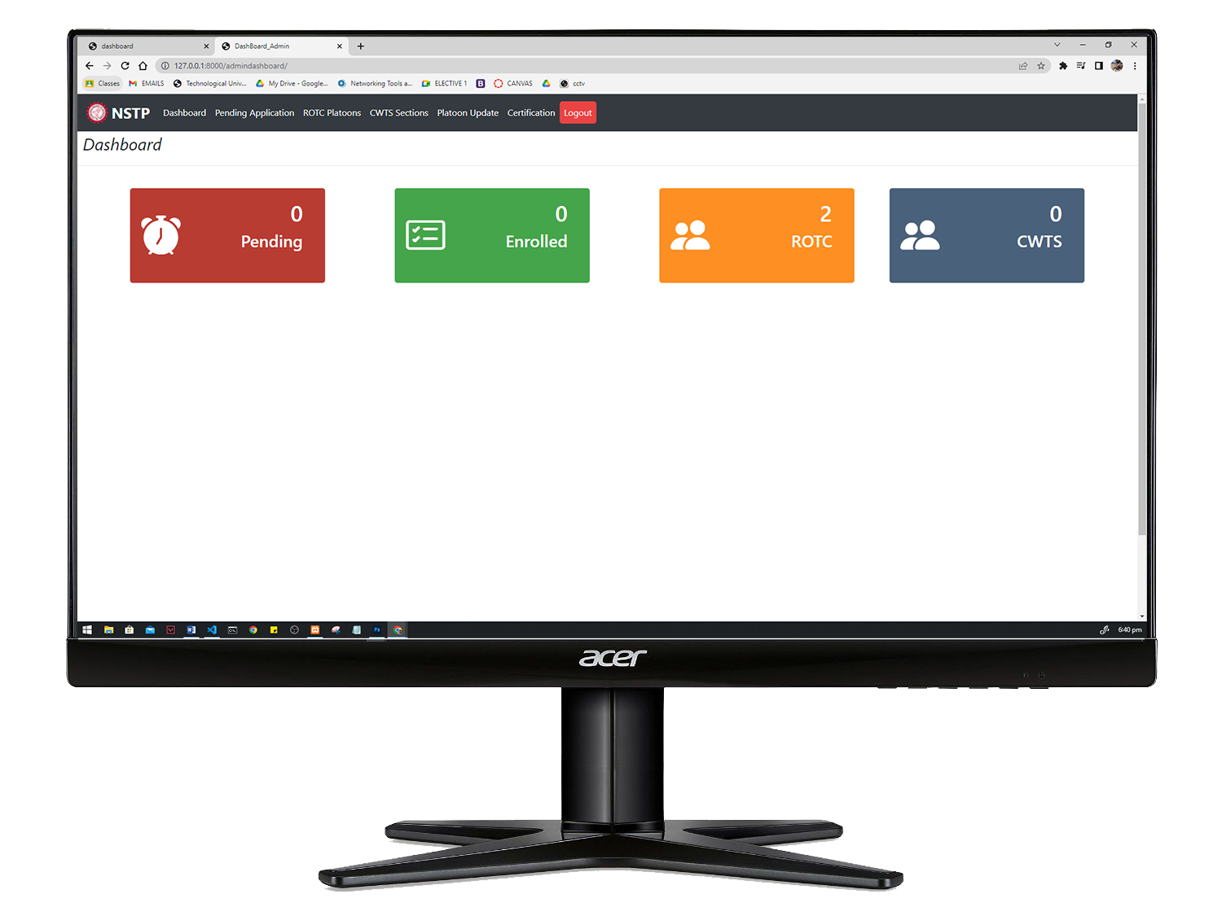

*Figure 20; Admin dashboard*

Figure 20 shows the admin dashboard of the system. This is where the admin will see the count of all students who are taking NSTP. Also the admin or staff will see the count of students inside the platoons and sections of the nstp.

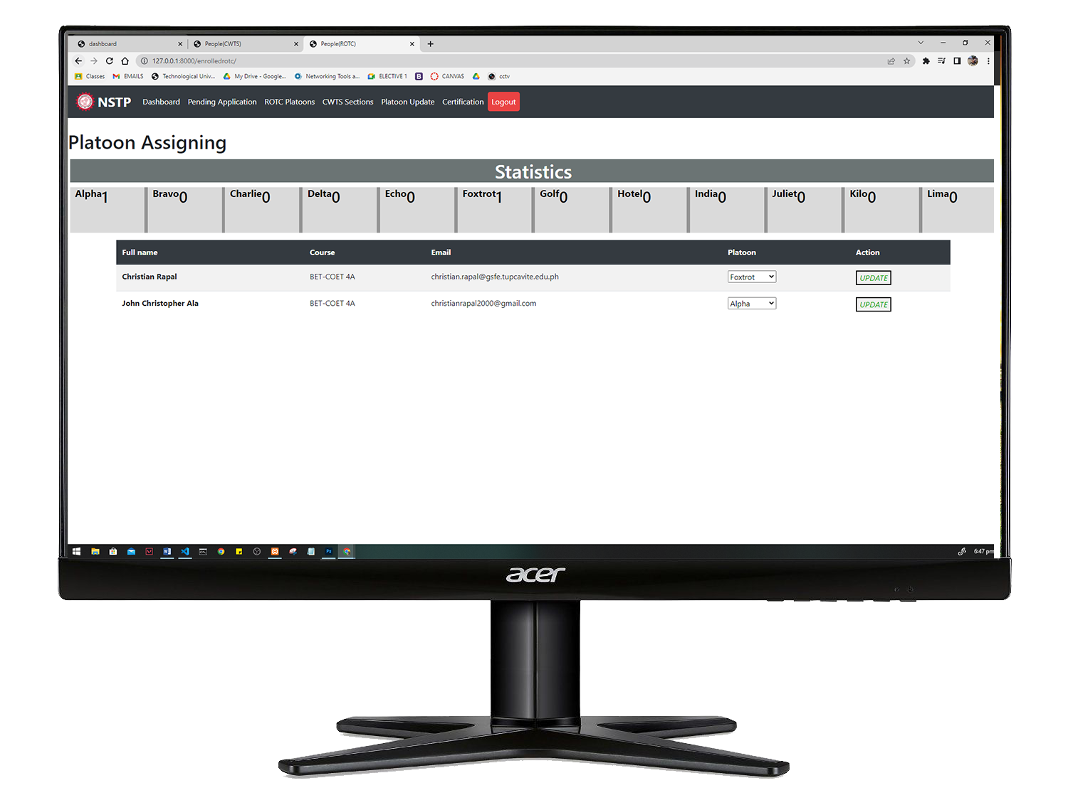

*Figure 21; Admin-platoon Assigning*

Figure 21 shows the User Interface (UI) of admin assigning platoons to enrolled Students. Once the students was assigned, the update will automatically appear on their dashboard.

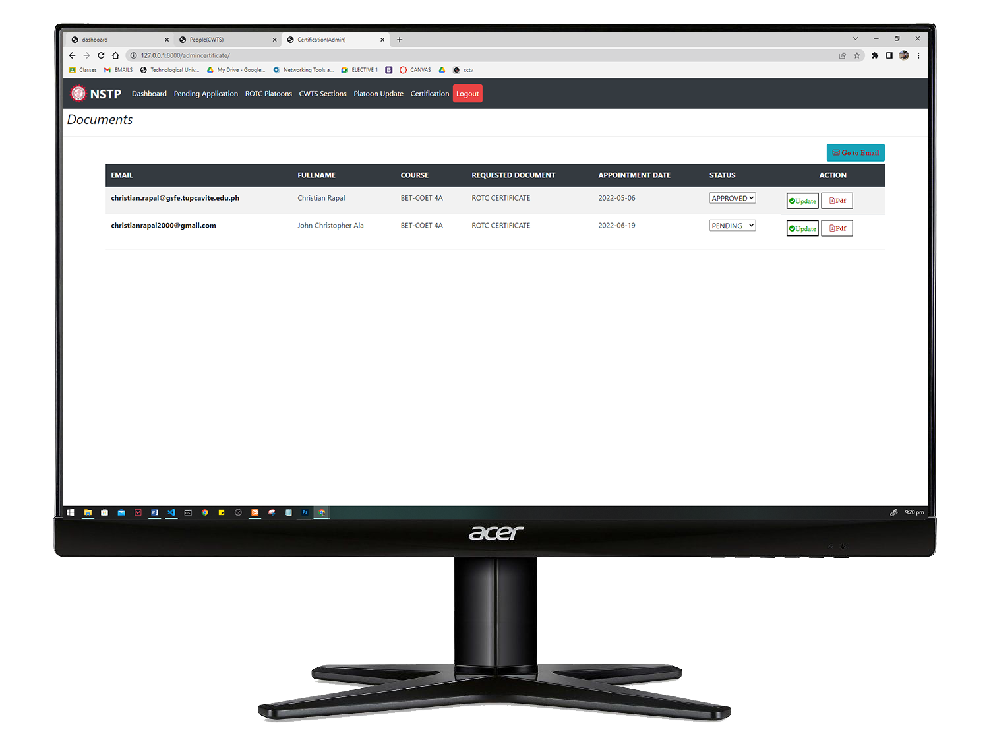

*Figure 22; Admin-Certification*

Figure 22 shows the User Interface (UI) of the admin certification part. This is where the requested certificate of students will be generated. This is the one click generation of certificate that makes it more convenient to staff who will use the system.

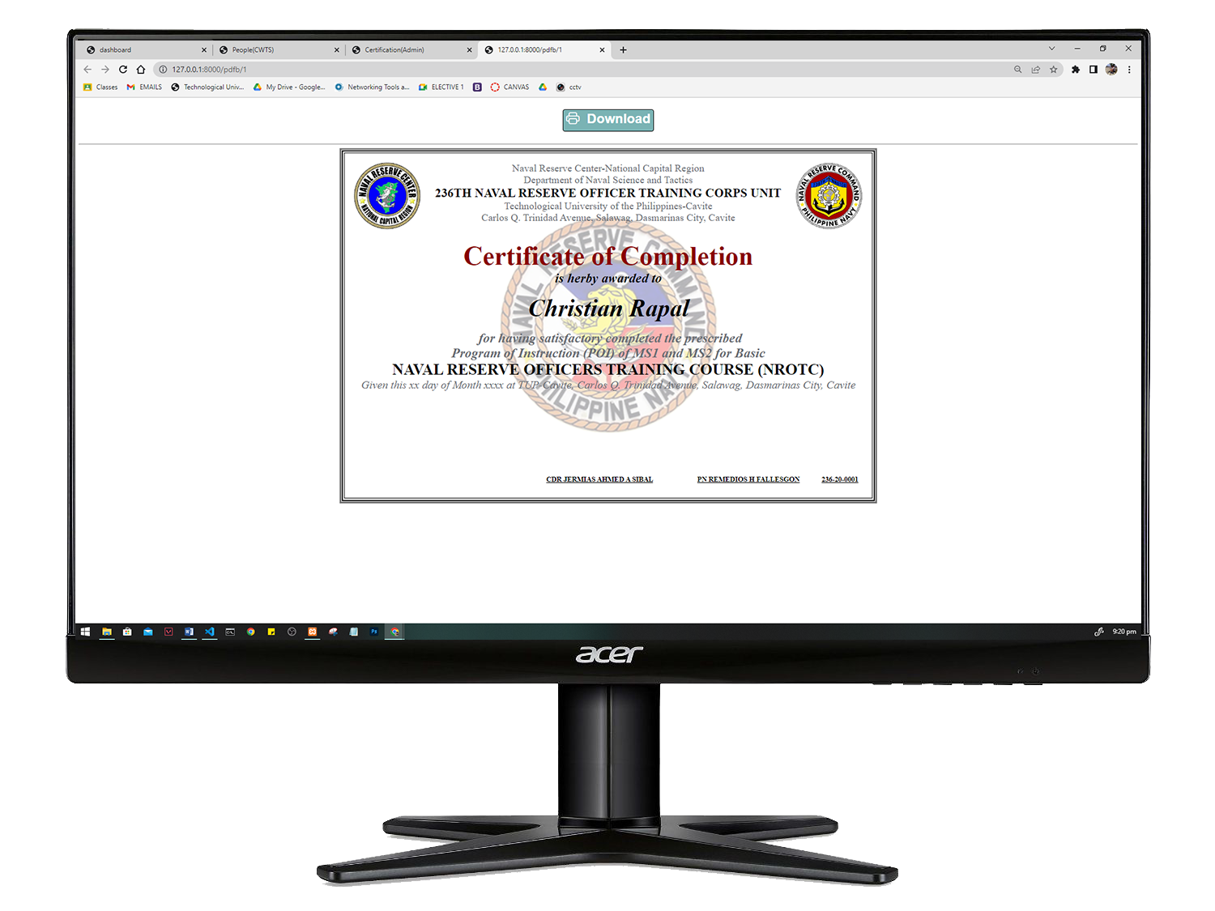

*Figure 23; Certificate Generated*

Figure 22 shows the User Interface (UI) of the admin certification part. This is where the requested certificate of students will be generated. This is the one click generation of certificate that makes it more convenient to staff who will use the system.

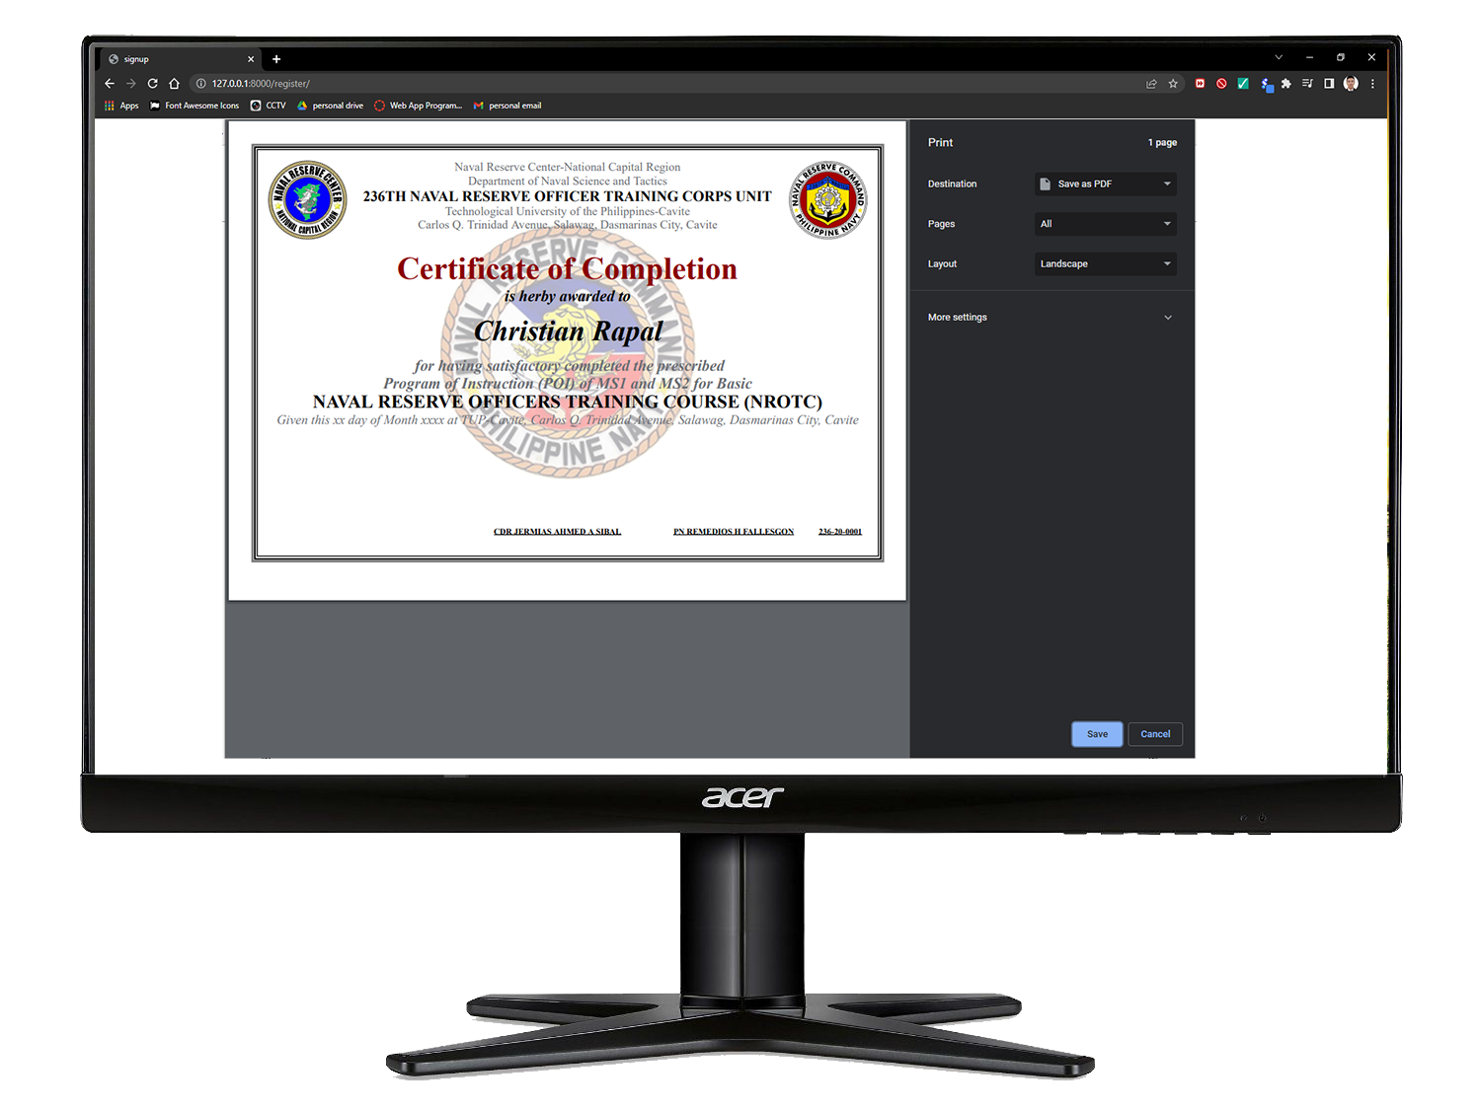

*Figure 24; Certificate Saving / Printing*

Figure 24 shows the Interface of saving or printing of the certificate generated by the system.

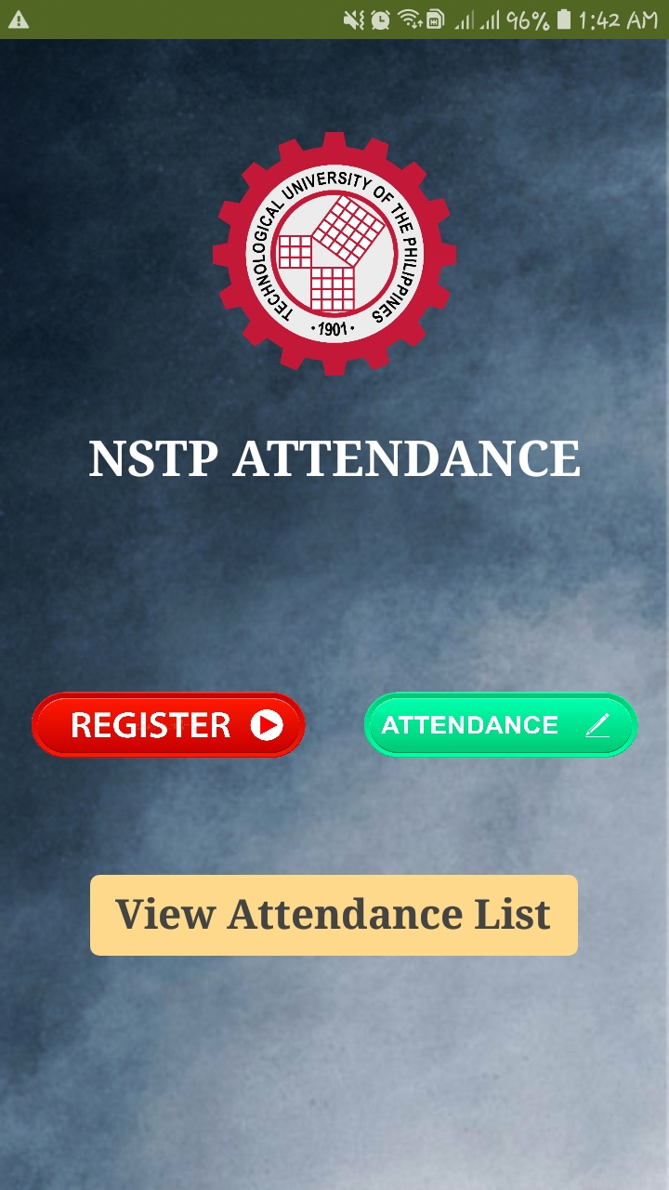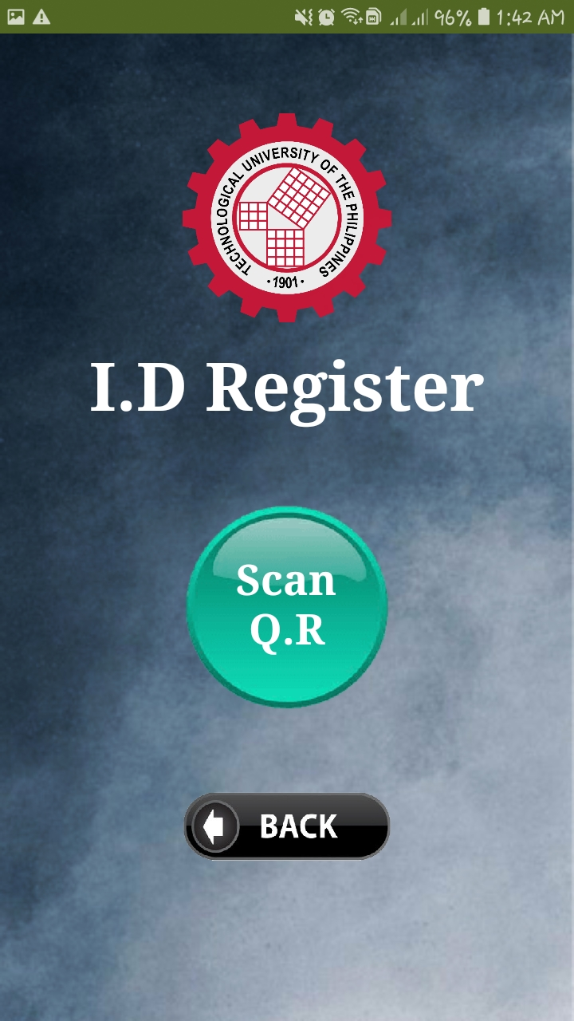

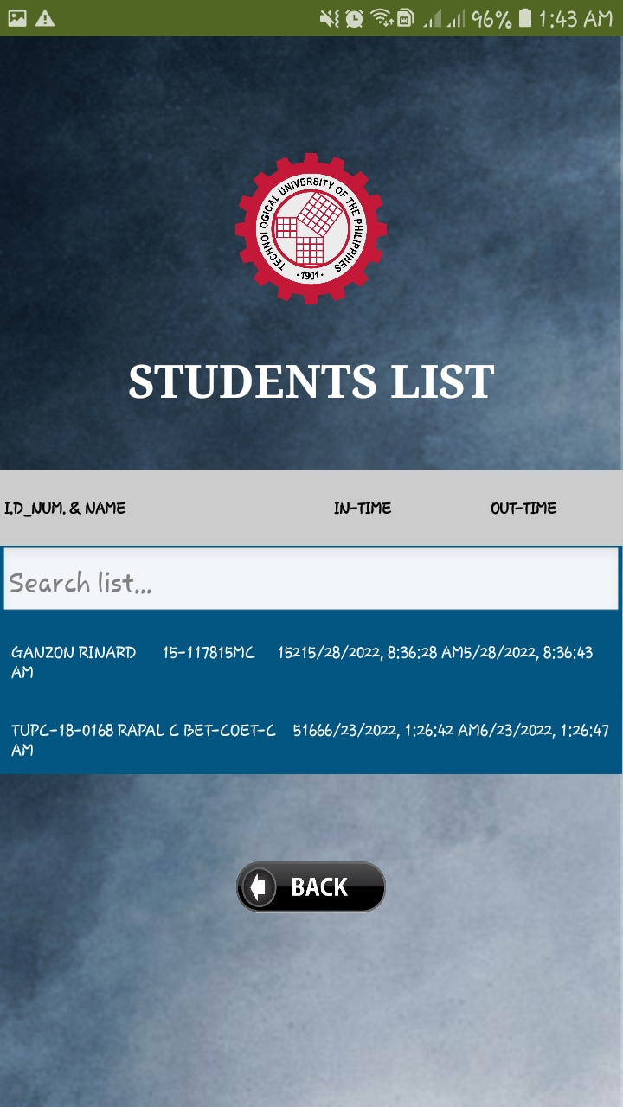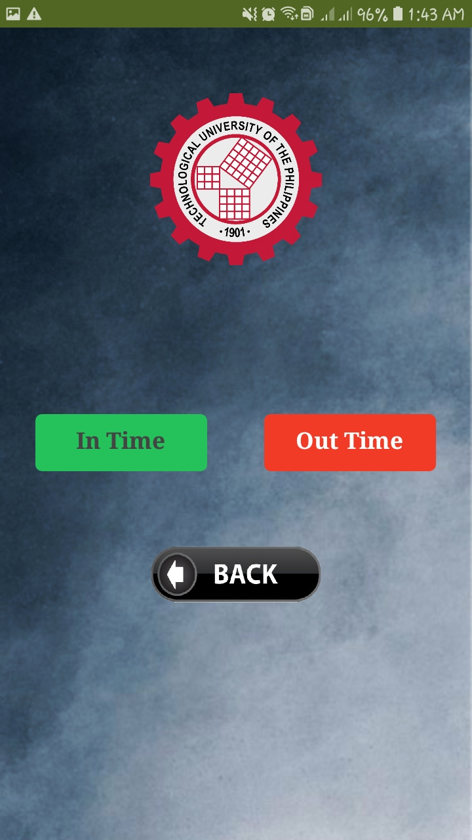

*Figure 25; UI of Attendance Scanner Using Mobile application*

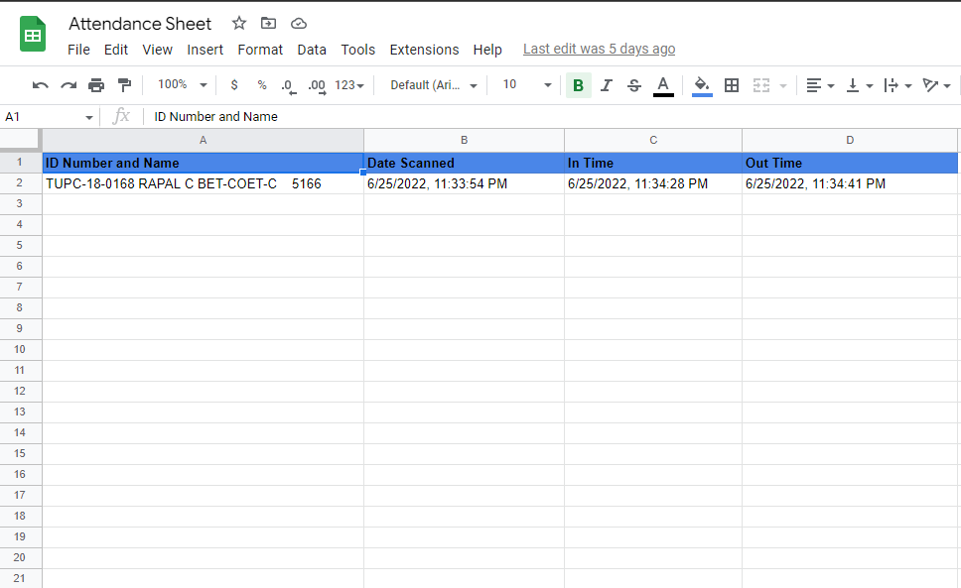

*Figure 26; Attendance Spreadsheet*

Figure 26 shows the spreadsheet of the attendance record of students, This record was taken by the mobile application created. This Spreadsheet was excluded from the Web app made.

**Operation and Testing Procedure**

The following operating method must be followed in order for the Nstp system to run properly.

In testing Nstp System for TUPC, the researchers manage to create a series of tests to check the functionality, accuracy and reliability. According to

the following conditions:

**Project Test Results:**

**Table No. 1**

*Likert Scale*

|  |  |
| --- | --- |
| **Numerical Rating** | **Descriptive Rating** |
| 5.0 | Excellent/Highly Acceptable |
| 4.0 | Very Good/Very Acceptable |
| 3.0 | Good/Acceptable |
| 2.0 | Fair/Fairly Acceptable |
| 1.0 | Poor/Not Acceptable |

**Table No. 2**

*Descriptive Interpretation of the Medium*

*Table no. 2 shows the numerical rating and the corresponding interpretation rating.*

|  |  |  |
| --- | --- | --- |
| **Numerical Scale** | **Statistical Limit** | **Verbal Interpretation** |
| 5 | 4.51 - 5.00 | Excellent |
| 4 | 3.51 - 4.50 | Very Good |
| 3 | 2.51 - 3.50 | Good |
| 2 | 1.51 - 2.50 | Fair |
| 1 | 1.00 - 1.50 | Poor |

**Project Test Results**

This shows the following results of the tests conducted in terms of Functionality, Accuracy and Reliability for displaying post wirelessly

The functionality of the NSTPSytem in the entire system is shown in Table 3 and 4

**Test Procedure for Functionality**

**Table No. 3**

Functionality of Registering, requesting of certificates, of students in Nstp to

|  |  |  |
| --- | --- | --- |
| **Test Conducted** | **Expected Output** | **Actual Output**  **Test 1 Test 2 Test 3** |
| Browse the system link within the network | System Log-in account will displayed |  |
| Enter all necessary information | Accounts will be successfully registered |  |
| Log-in with valid credentials | User account can access the system |  |
| Submit a request | Request will be displayed at at pending list |  |

*Table 3*

**Table No. 4**

Functionality of Signing in, approving of enrollment, generating of certificates, uploading of files, Archiving of all documents of students in Nstp

|  |  |  |
| --- | --- | --- |
| **Test Conducted** | **Expected Output** | **Actual Output**  **Test 1 Test 2 Test 3** |
| Browse the system link within the network | System Log-in account will displayed |  |
| Log-in with valid credentials | User account can access the system |  |
| View the pending list or registeration | All students want to register will be displayed |  |
| View the certification list | All request will be displayed |  |
| Choose a files to upload in Nstp | All files uploaded will be displayed |  |
| Archieve all documents | All documuents of the students will be save in archive |  |
| Taking the attendance of students | Names and time in and out of the student will be displayed |  |

*Table 4*

**Test Procedure for Accuracy**

The Accuracy of the NSTPSytem in the entire system is shown in Table 5

**Table No. 5**

|  |  |  |
| --- | --- | --- |
| **Test Conducted** | **Expected Output** | **Actual Output**  **Test 1 Test 2 Test 3** |
| View the pending list or registeration | All students want to register will be displayed |  |
| Generating of certificates | Certificates will be generated with the name of the students |  |
| Taking the attendance of students | Names and time in and out of the student will be displayed |  |

*Table 5*

**Test Procedure for Reliability**

**Table No. 6**

Reliability of Registering, requesting of certificates, of students in Nstp to

|  |  |  |
| --- | --- | --- |
| **Test Conducted** | **Expected Output** | **Actual Output**  **Test 1 Test 2 Test 3** |
| Log-in invalid user account | The system is not accessible and Error message will be displayed |  |
| Log-in valid user account | The user account can access the system |  |

*Table 6*

**Project Evaluation Results**

**Table No. 7**

Functionality performance of the Nstp System

|  |  |
| --- | --- |
| **Indicators** | **Mean** |
| Ease of operation |  |
| Provision for comfort and convenience |  |
| User friendliness |  |
| Total mean average |  |

**Table No. 8**

Performance of the Nstp System

|  |  |
| --- | --- |
| **Indicators** | **Mean** |
| Color |  |
| Attractiveness |  |
| Appropriate in size |  |
| Total mean average |  |

**Table No. 9**

Workability Performance of theNstp System

|  |  |
| --- | --- |
| **Indicators** | **Mean** |
| - |  |
| - |  |
| - |  |
| - |  |

**References:**

**QR Code**

[Iranna M Shettar](https://www.researchgate.net/profile/Iranna-Shettar-2) (April 2016), *Quick Response (QR) Codes in Libraries: Case study on the use of QR codes in the Central Library, NITK*

<https://www.researchgate.net/publication/301887341_Quick_Response_QR_Codes_in_Libraries_Case_study_on_the_use_of_QR_codes_in_the_Central_Library_NITK>

**BAR Code**

Denso Wave (2022), What is a barcode, https://www.denso-wave.com/en/adcd/fundamental/barcode/barcode/index.html

**Certificate Generator**

Bharti Chikankar, Sidhant Jaiswal (07-09-2020), Certificate Generation System

<https://www.journals.resaim.com/ijresm/article/view/251>

**Web Application**

Indeed Editorial Team(02-26-2020), What is a Web Application

<https://www.indeed.com/career-advice/career-development/what-is-web-application>

**Online Enrollment**

Patrick H. H. Then(November 2006), What is Online Enrollment System

<https://dl.acm.org/doi/10.1145/1181216.1181300>

**Attendance using Qr code Scanner**

[Fadi Almasalha](https://www.researchgate.net/profile/Fadi-Almasalha) (January 2014), [Smart Attendance System](https://www.researchgate.net/project/Smart-Attendance-System): [International Journal of Advanced Computer Science and Applications](https://www.researchgate.net/journal/International-Journal-of-Advanced-Computer-Science-and-Applications-2156-5570)

<https://www.researchgate.net/publication/275605455_A_Students_Attendance_System_Using_QR_Code>

**Html**

[A](https://www.investopedia.com/contributors/53677/)dam Hayes (11-13-2020), What is Html

<https://www.investopedia.com/terms/h/html.asp>

**Database**

**Oracle (2022), What is Database**

<https://www.oracle.com/ph/database/what-is-database/>

**Css**

TechTerms.com (2006), What **is Css**

<https://techterms.com/definition/css>

**Javascript**

[Dillion Megida](https://www.freecodecamp.org/news/author/dillionmegida/) (March 29, 2021), What is JavaScript

<https://www.freecodecamp.org/news/what-is-javascript-definition-of-js/>

**Python Web Framework**

[Omed Habib](https://www.appdynamics.com/blog/author/omed/) (January 25 2016), What is Python Web Framework

<https://www.appdynamics.com/blog/engineering/an-introduction-to-python-frameworks-part-1/>

**Django**

Djangoproject (2005), What is Django

<https://www.djangoproject.com/>

**Xampp**

Apachefriends (2022), What is Xampp

https://www.apachefriends.org/